DECLARATION
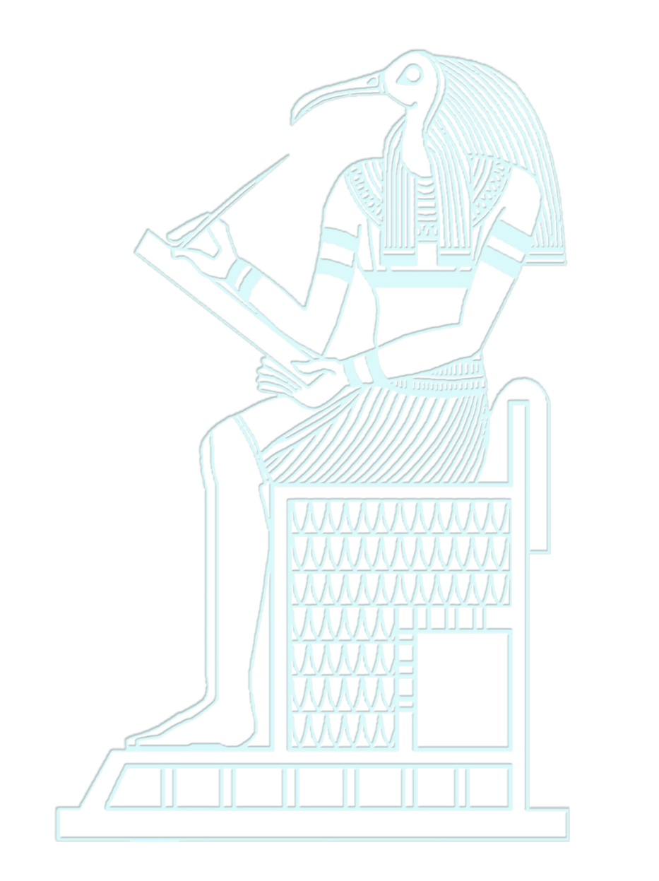
For Verifying the Certificate
- You should send a fax or a letter from the employer with copy from the certificate.
- If the graduate is an Egyptian and work in Egypt, he should pay (50 bound) for each certificate.
- If the graduate is an Egyptian and work abroad, he should pay (10 dollar) for each certificate.
- If the graduate is a foreigner, he should pay (50 dollar) for each certificate.
- The amount should be paid in the account of:
- THE ARAB AFFRICAN INTERNATIONAL BANK
- The account by the Egyptian currency n:(9/450/87811/3)
- The account by the Foreign currency n:(4/082/17748/1)
N.B

- You can send a copy from both the certificate and the receipt by the email :( student.affairs @cu.edu.eg)or
- Fax n: (202+35735986),202+35726498) Khamis Omran

