The Innovation Events series aims to promote innovation and entrepreneurship awareness amongst staff and students, and enhance academia-industry dialogue in innovation. The ultimate aim is to enable innovation in the service of the socio-economic development of society.
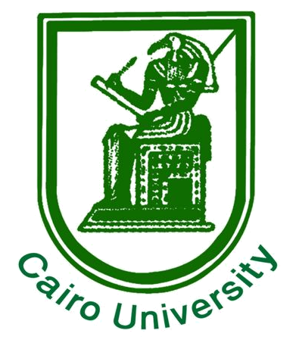
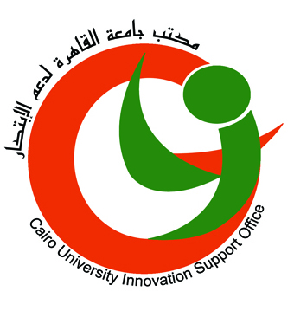
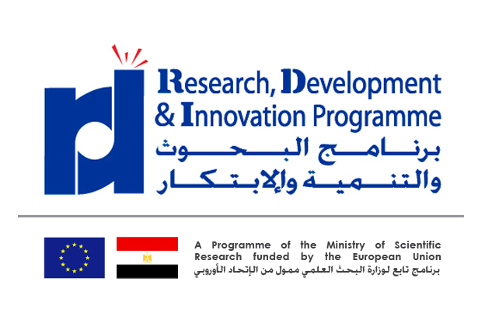
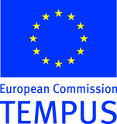

Innovation Events @ Cairo University

Innovety LLC. in collaboration with Cairo University Chair on Innovation and
Cairo University Innovation Support Office,
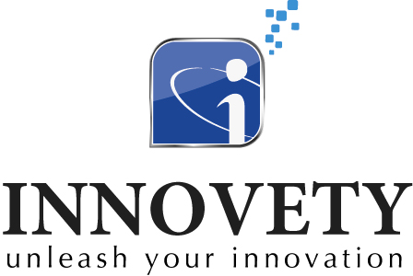

Has the pleasure to invite

Cairo University Senior Staff to a special EU-sponsored seminar on:

Intellectual Property Rights

Date: Sunday 19th January 2014

Venue: Cairo University Conference Centre (Student Hostel Complex)

Time: 10:30 AM

ATTENDANCE IS FREE OF CHARGE

For regular updates, please like & regularly check our Facebook page: http://www.facebook.com/Innovation.Cairo

Visit our web site: http://www.innovate.cu.edu.eg • Facebook: http://www.facebook.com/Innovation.Cairo
Telephones: +20 1067510470 or (2nd alternative) +20 0100 12 44 309

Provisional Session Program (final program on Facebook page)

10:30 | Registration & welcome
10:45 | Welcome notes
11:15 | IPR Issues, part 1
12:45 | Coffee break
1:15 | IPR Issues, part 2
2:45 | Q&A
3:00 | How can innovation be supported in University?
4:00 | Conclusion

IPR Issues Session Contents
1. Material VS. Intellectual Value Chain
2. An introduction to Intellectual Assets (IA), Intellectual Properties (IP), and Intellectual Capital (IC)
3. Extracting Value from IP using the Intellectual Value Star
4. Using IP to build Innovations, Ventures, and Markets
5. Using IP to create Financial Value
6. Basics of Intellectual Property
7. Introduction to IP Strategy
8. Mapping IP to the overall strategy using the value hierarchy.
9. Using patent information services, license agreements, and contractual agreements to create value
10. The role of IP in Open Innovation and Technology Transfer
11. Case Studies

Speaker Biography: Mohamed Kash

 | Mohamed Kash, has hands-on experience in Intellectual Properties, IP strategies, Technology Commercialization, market research, and business models design. Kash attended his Masters of science in Intellectual Capital Management at Chalmers University in Sweden and he consulted several cases in commercializing university research, developing technology standards, using different licensing structures, packaging concepts and Soft-IP, developing and commercializing virtual products, patents landscaping, IA assessments, drafting patent claims, license agreements, and trademark usage policies, and constructing IP-based business models. Kash is experienced in using IPRs, contracts, business relations, license agreements, and business plans as tools for new business creation.  Working with the Science and Technology Development Fund (STDF) as a Technology Commercialization Specialist, Kash gained experience in technology transfer and became knowledgeable of the Egyptian IP law and the required procedures. He has a deep understanding of the innovation ecosystem and barriers in Egypt and he recommended an innovation model to be implemented in Egypt after conducting a gap analysis covering existing innovation players. Kash is also certified by the European Patent office to conduct courses covering Patent search, IP in Business Practice, and Building and Defending IP Value.  Kash is also a serial entrepreneur. He started three technology companies Fi-Me, Yadget, and Zaagel.com. He has gone through the process of acceleration and fund raising in Egypt and Silicon Valley. He has experience in feasibility study, small firms finance, start-up operations, business development, and digital marketing. He also got training in Europe on managing technology incubators and he mentored startups in the areas of IP, business models, and pitching to investors.

